samlogo_blue_pc.tif

**New Perspectives** Excel 2013

Tutorial 3: SAM Project 1a

Spring Software

ENHANCE A TIMESHEET

Project Goal

M Project Name

Project Goal

# PROJECT DESCRIPTION

Devon Hastings is the human resources director for Spring Software, a software development company in Cambridge, Massachusetts. He has created a workbook for employees to use in recording the hours they work. He would like your help finishing the timesheet.

# GETTING STARTED

* Download the following file from the SAM website:
  + **NP\_Excel2013\_T3\_P1a\_*FirstLastName*\_1.xlsx**
* Open the file you just downloaded and save it with the name:
  + **NP\_Excel2013\_T3\_P1a\_*FirstLastName*\_2.xlsx**
  + *Hint:* If you do not see the **.xlsx** file extension in the Save file dialog box, do not type it. Excel will add the file extension for you automatically.
* With the file **NP\_Excel2013\_T3\_P1a\_*FirstLastName*\_2.xlsx** still open, ensure that your first and last name is displayed in cell B6 of the Documentation sheet. If cell B6 does not display your name, delete the file and download a new copy from the SAM website.

# PROJECT STEPS

1. On the *Employee List* worksheet, select cells **A1:B1** and then use the **Format Painter** copy the **format only** to the range **A2:B9**.
2. In cell B1 enter **bs001**, in cell B2 enter **cg001**, in cell B3 type **dh001**, and then use Flash Fill to automatically fill in the values for the range **B3:B9**.
3. On the *Employee Timesheet* worksheet, merge and center the range **A1:D1**, and then format the range using the **Title** Cell Style (5th column, 1st row in the Titles and Headings section of the Cell Styles panel).
4. Merge and center the range **A2:D2**, and then change the font to **Arial** and the font size to **14 pt**.
5. Format the range **A9:D9** using the **Heading 3** cell style (3rd column, 1st row in the Titles and Headings section of the Cell Styles panel) and then center the range **A9:D9**.
6. In cell C5, create a formula using the VLOOKUP function to look up the value of cell C4 (in the current worksheet) in the range **A1:B9** on the *Employee List* worksheet and then return the value in the second column of that range. Use **FALSE** as value of the Range\_Lookup argument to specify an exact match lookup.
7. In cell B7, use the **TODAY** function to display the current date.
8. Use **AutoFill** to fill the range **B11:B23** based on cell B10.
9. In cell D10, create a formula that uses the IF function to check if the value in cell C10 is equal to 0.
   1. If this condition is true, the current cell should be made empty (that is, equal to "").
   2. If this condition is false, the current cell should display the result of multiplying cell C10 (hours) by cell D7 (hourly wages). Use a relative reference to cell C10 and an absolute references to cell D7 so that the formula can be copied to other cells.
10. Copy the formula from cell D10 to all cells in the range **D11:D23**.
11. In cell C24, create a formula that uses the SUM function to total cells **C10:C23**.
12. In cell D24, enter a formula that uses the SUM function to total cell D10:D23.
13. Format C10:C24 with the Number format, showing two decimal places.
14. Format cell D7 with the Currency number format, showing two decimal places, and then format the range D10:D24 with the same format.
15. Format the range **A24:D24** as bold and then add an outside border around this range.
16. In cell C26, create a formula that uses the **MAX** function to display the largest value from the range **C10:C23**.
17. In cell C27, create a formula that uses the **MIN** function to display the smallest value from the range **C10:C23**.
18. In cell C28, create a formula that uses the **AVERAGE** function to display the average of the values in the range **C10:C23**.
19. In cell C29, create a formula that multiplies the value in cell C28 by 7 (the number of days in a week).

Your workbook should look like the Final Figures on the following pages. Save your changes, close the workbook, and exit Excel. Follow the directions on the SAM website to submit your completed project.

# Final Figure 1: Employee Timesheet worksheet

# 

Microsoft product screenshots used with permission from Microsoft Corporation.

Copyright © 2014 Cengage Learning. All Rights Reserved.

# Final Figure 2: Employee List worksheet

**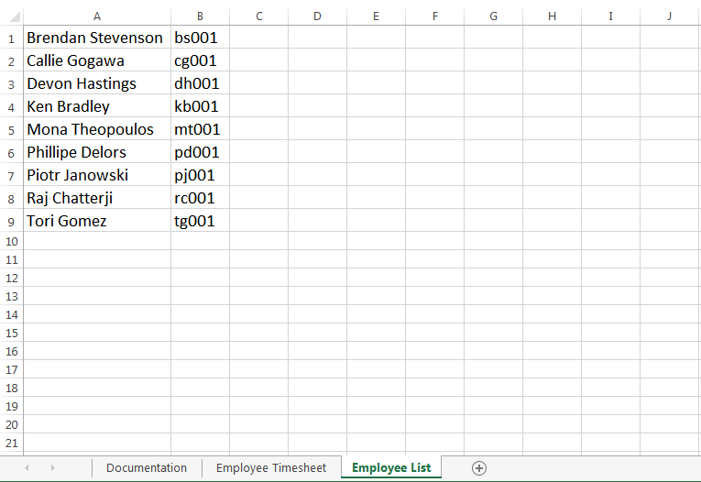**

Copyright © 2014 Cengage Learning. All Rights Reserved.